**REPORT Problem 3 – Anti-Lock Braking System (ABS System)**

A four Wheeler is to decelerate from a speed of 44 m/s to stand still without wheel locking. The coefficient of friction between wheel and road is already known. The desired wheel slip in the project for Condition 1 is set to 0.2 and in Condition 2; the signal builder is used to set the desired wheel slip i.e. different desired wheel slip at different instance. The output side of the system will show the slip over time, vehicle speed, Stopping distance and the wheel speed.

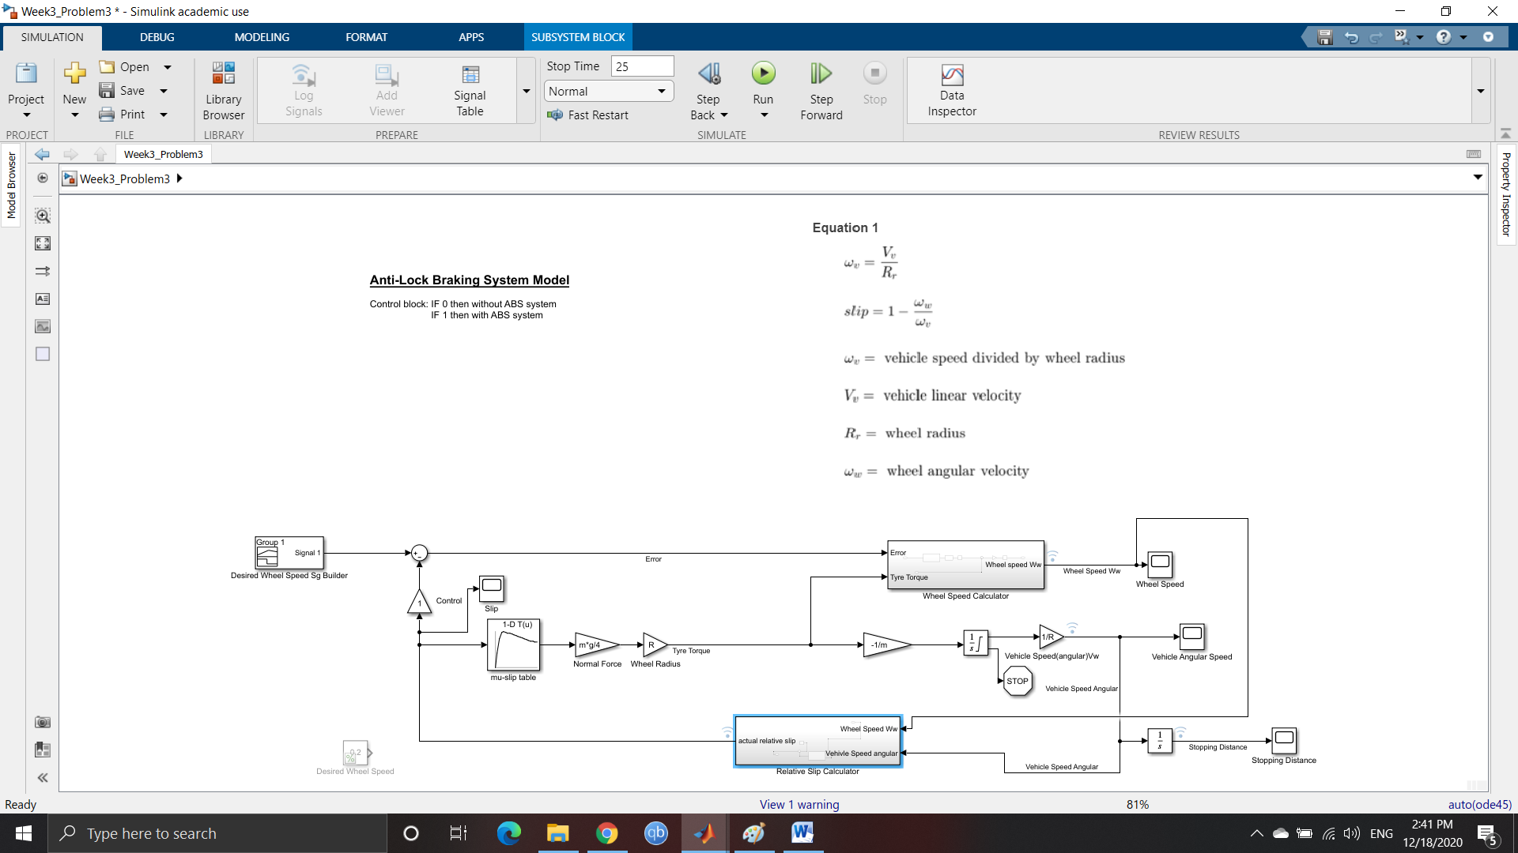

ABS System using Simulink

A Bang-Bang Controller is designed and is converted to subsystem and is present inside the Wheel Speed Calculator sub system, where the output is 1 when the input is greater than 0 and output is -1 when input is less than 0. The Integrator Limiters are configured with certain conditions.

The Matlab Simulink Skills used in this Project are : Callbacks , Data Inspector, Solver selection Strategy ,MATLAB Function Block, Look-Up Table and Signal builder.

1. Callbacks

Callback Function used in this Project is for setting the values of the parameters or variables. The Post Load Fcn is used so that the variables are effective after loading of the project.

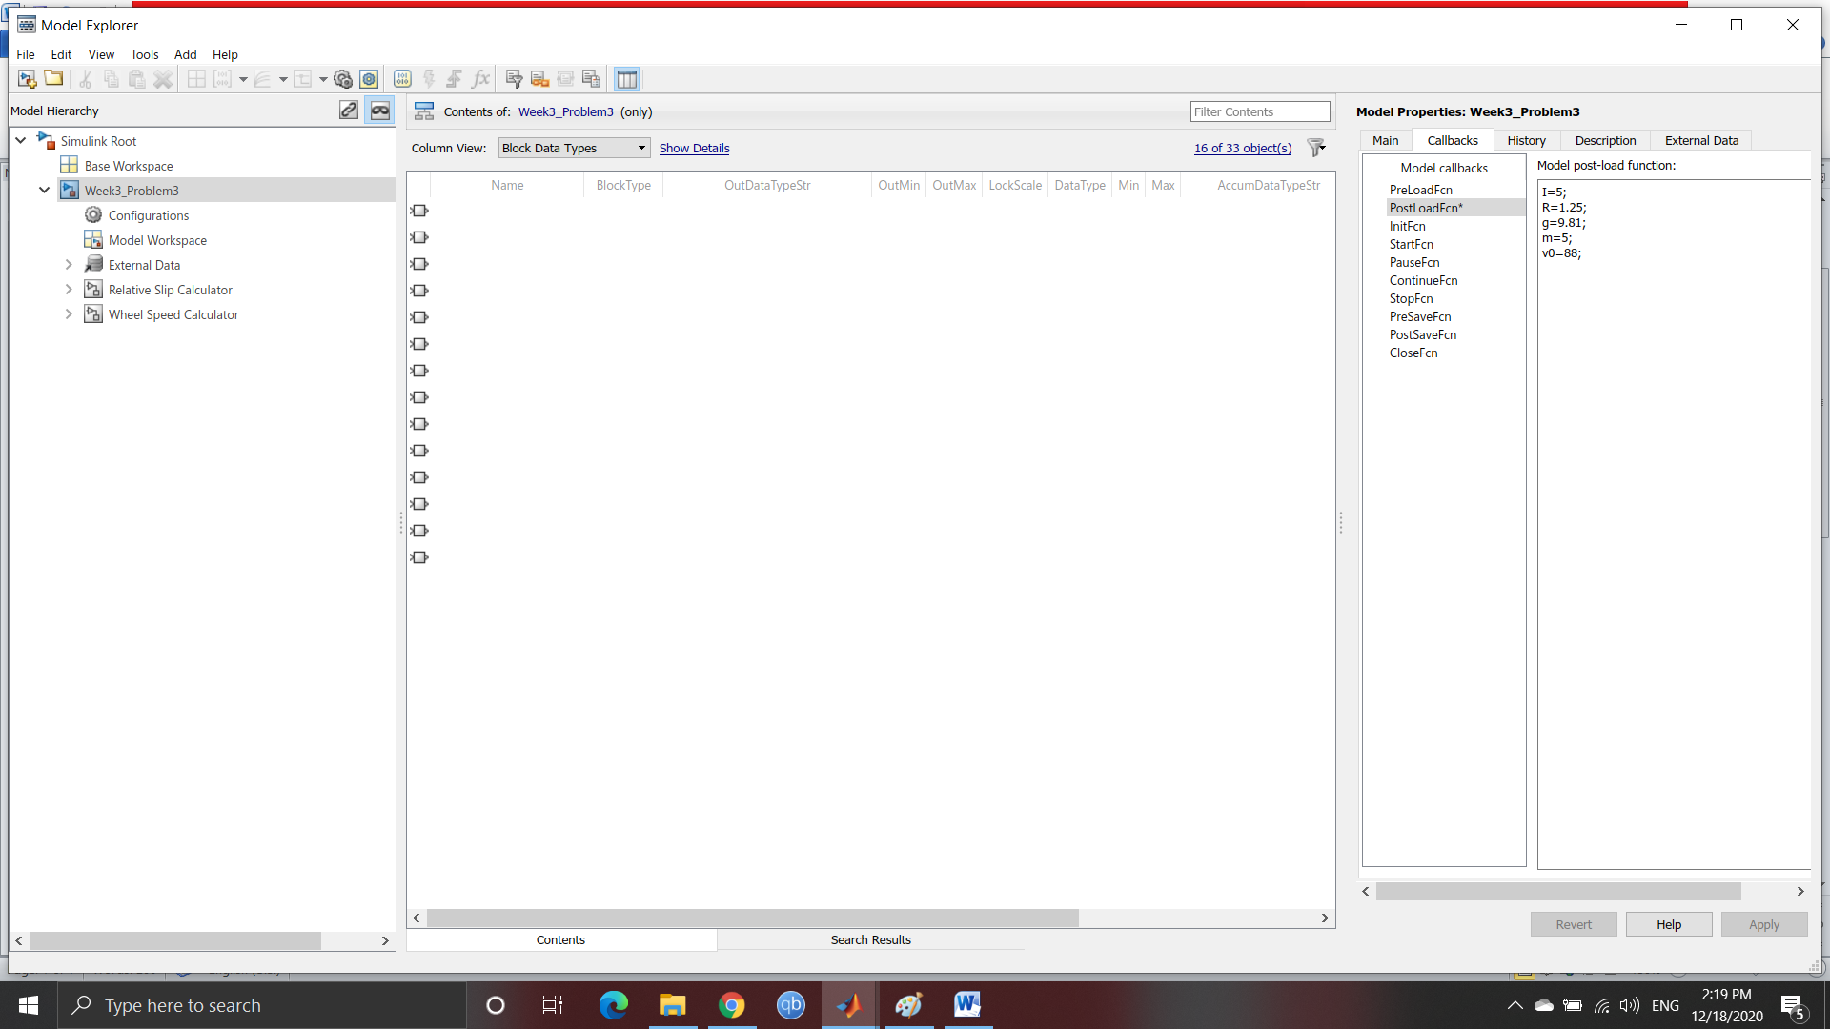

Post Load Fcn in CallBack Functions

1. Data Inspector

The signals are logged whose output has to be observed. After every run with different conditions the data inspector shows the output for the selected signals. The signals that are logged are: Relative Slip Calculator (Slip), Vehicle Speed, Wheel Speed and the Stopping Distance.

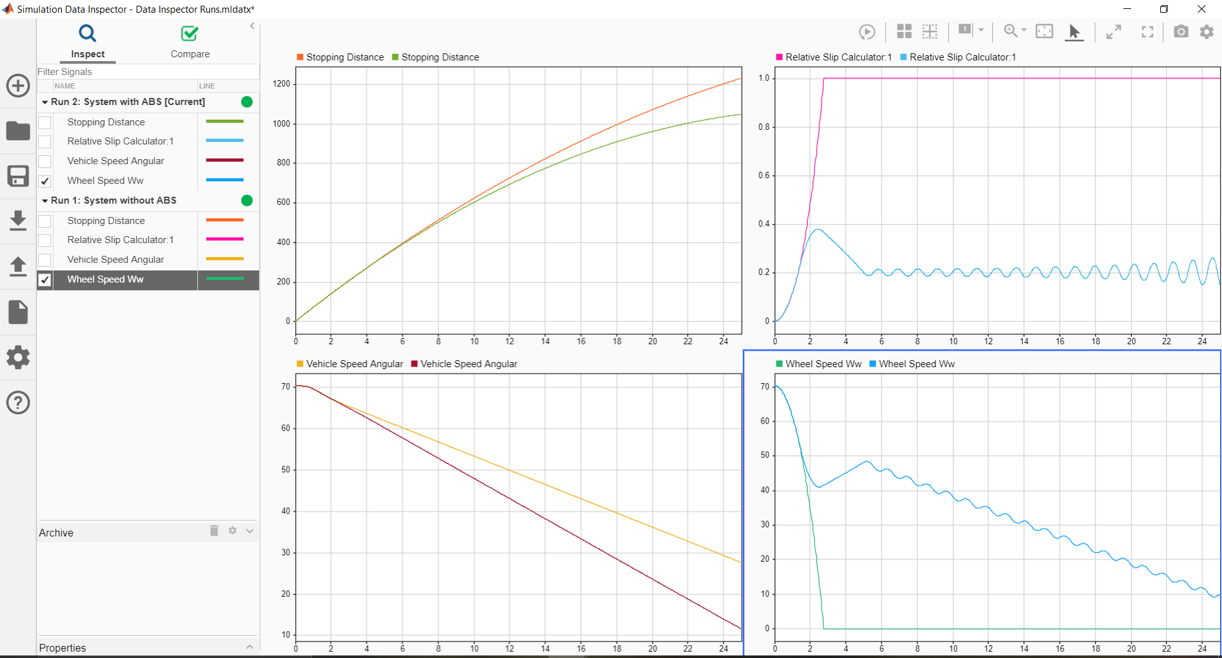

Data Inspector output for Comparison of With and Without ABS system

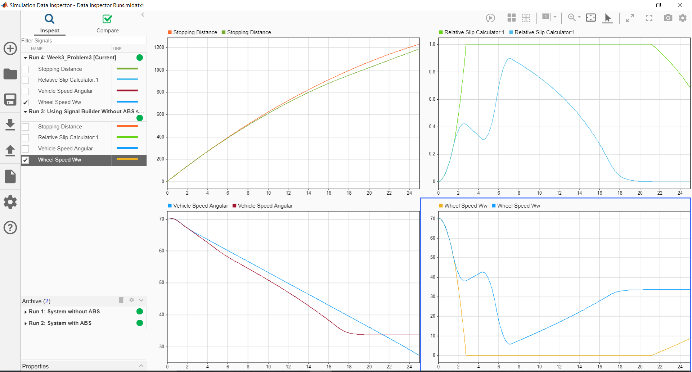

Data Inspector output for Comparison of With and Without ABS system using Signal Builder

1. Solver selection strategy

Solver selected for this project is the ode45 Dormand Prince Method because the ODE in the project is time and state dependent. The change in distance, slip, wheel speed and vehicle speed are always measured against time so this system is time dependent.

1. MATLAB function block

The Matlab Function block in this Project is in Relative Slip Calculator Sub System where there is a requirement of dividing two signals Wheel speed Ww by Vehicle Speed Angular. So the Matlab Function Block is used to the following Operation.

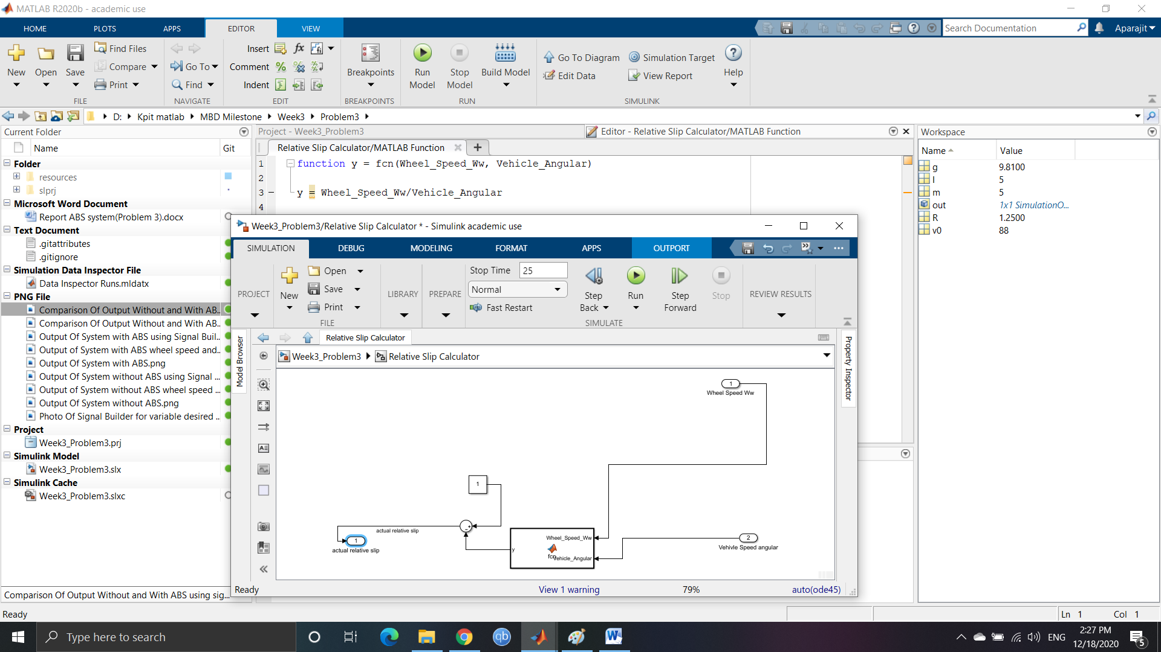

Matlab Function Block and its Function

1. Look-up table

The use of Look-Up table is used in the mu-slip table where the corresponding mu value is calculated or is the output for the corresponding input slip. For the changing slip, the mu value also changes and the speed of the vehicle speed and the wheel speed changes.

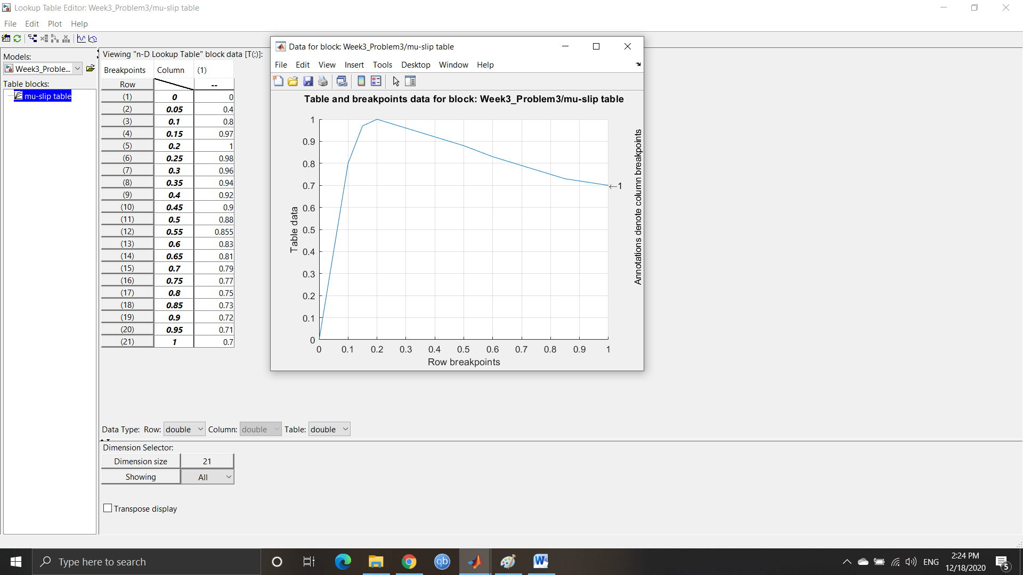

Look Up Table for mu-slip table

1. Signal Builder to generate test signals

The use of Signal Builder is for the input side with changing slip value so the output can be observed for the changing input slip values.

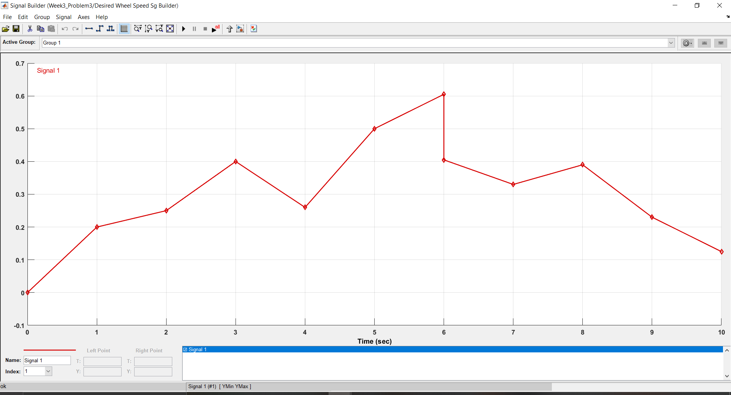

Signal Builder designed signal